

**ASSIGNMENT # 4**

**DESIGN DEFECTS & RESTRUCTURING (BCS-8A)**

**HASSAN ALI**

**K20-1052**

**April 20, 2024**

**QUESTION**

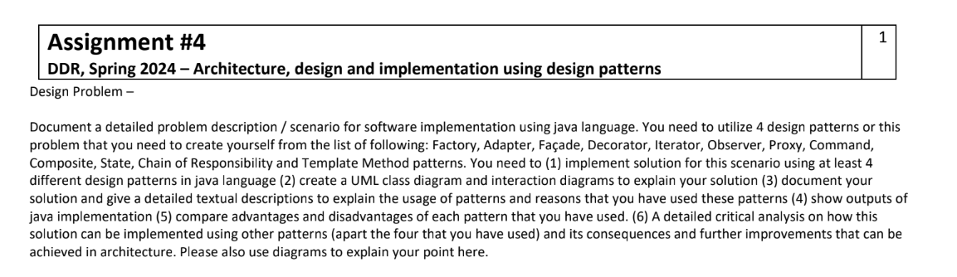

**Problem Overview (Employee Management & Recruitment System):**

**The proposed HR system is designed to facilitate efficient management of employee data, attendance tracking, salary computation, and reporting for HR personnel, and managing the hiring process of potential candidate.**

**System Functionalities:**

* **Employee Information Management: HR managers must have the capability to add, remove, and update employee records, including details such as name, job role, and hourly wage rate.**
* **Time and Attendance Tracking: The system should record employee attendance data, capturing the clock-in and clock-out times for each shift.**
* **Compensation Calculation: Based on the recorded hours worked and the respective hourly rates, the system should compute the salary for each employee.**
* **Reporting and Analytics: The system should generate comprehensive reports on employee attendance, performance metrics, and payroll summaries.**

1. **Solution using 4 patterns**
   1. **Factory Pattern**

**import java.util.ArrayList;**

**import java.util.List;**

**// Employee interface**

**interface Employee {**

**void displayInfo();**

**double calculateSalary(int hoursWorked);**

**}**

**// Concrete implementations of employees**

**class FullTimeEmployee implements Employee {**

**private String name;**

**private String position;**

**private double hourlyRate;**

**public FullTimeEmployee(String name, String position, double hourlyRate) {**

**this.name = name;**

**this.position = position;**

**this.hourlyRate = hourlyRate;**

**}**

**public void displayInfo() {**

**System.*out*.println("Name: " + name);**

**System.*out*.println("Position: " + position);**

**System.*out*.println("Hourly Rate: $" + hourlyRate);**

**}**

**public double calculateSalary(int hoursWorked) {**

**return hoursWorked * hourlyRate;**

**}**

**}**

**class PartTimeEmployee implements Employee {**

**private String name;**

**private String position;**

**private double hourlyRate;**

**public PartTimeEmployee(String name, String position, double hourlyRate) {**

**this.name = name;**

**this.position = position;**

**this.hourlyRate = hourlyRate;**

**}**

**public void displayInfo() {**

**System.*out*.println("Name: " + name);**

**System.*out*.println("Position: " + position);**

**System.*out*.println("Hourly Rate: $" + hourlyRate);**

**}**

**public double calculateSalary(int hoursWorked) {**

**return hoursWorked * hourlyRate;**

**}**

**}**

**// Factory to create different types of employees**

**class EmployeeFactory {**

**public static Employee createEmployee(String type, String name, String position, double hourlyRate) {**

**switch (type) {**

**case "FullTime":**

**return new FullTimeEmployee(name, position, hourlyRate);**

**case "PartTime":**

**return new PartTimeEmployee(name, position, hourlyRate);**

**default:**

**throw new IllegalArgumentException("Invalid employee type: " + type);**

**}**

**}**

**}**

**// Attendance tracking class**

**class AttendanceTracker {**

**public void trackAttendance(Employee employee, int hoursWorked) {**

**System.*out*.println(employee.getClass().getSimpleName() + " " + employee.calculateSalary(hoursWorked));**

**}**

**}**

**public class main_1 {**

**public static void main(String[] args) {**

**// Create employees using the factory**

**Employee fullTimeEmployee = EmployeeFactory.*createEmployee*("FullTime", "John Doe", "Manager", 30.0);**

**Employee partTimeEmployee = EmployeeFactory.*createEmployee*("PartTime", "Jane Smith", "Clerk", 15.0);**

**// Display employee information**

**System.*out*.println("Full-Time Employee Information:");**

**fullTimeEmployee.displayInfo();**

**System.*out*.println("\nPart-Time Employee Information:");**

**partTimeEmployee.displayInfo();**

**// Track attendance and calculate salary**

**AttendanceTracker tracker = new AttendanceTracker();**

**tracker.trackAttendance(fullTimeEmployee, 40);**

**tracker.trackAttendance(partTimeEmployee, 20);**

}

}

**Output:**

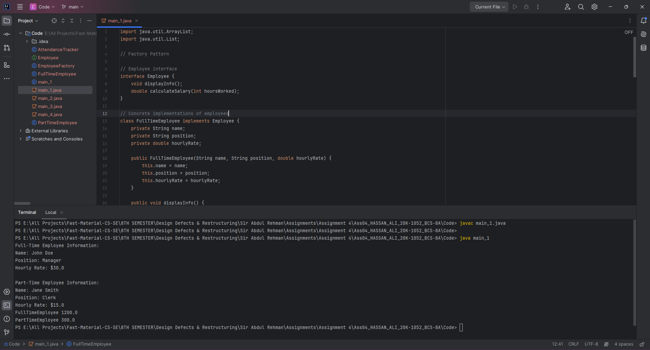

**Class Diagram:**

**Activity Diagram:**

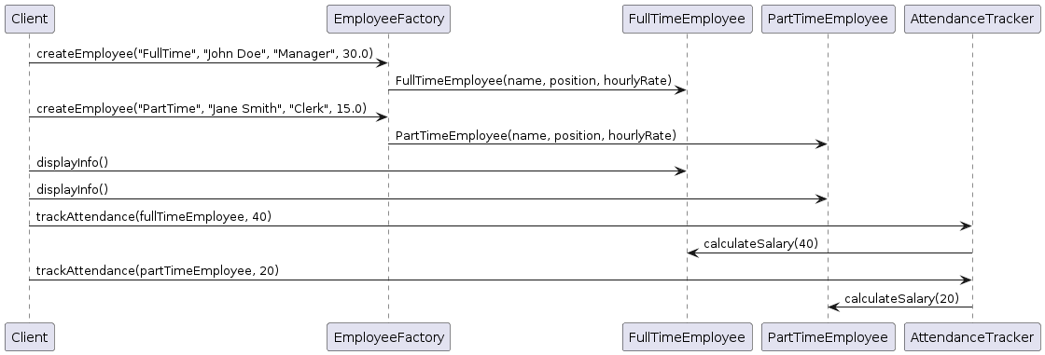

**Explanation**

**1. Encapsulation of Object Creation Logic:**

The Factory pattern encapsulates the logic for creating objects. In the HR system, the `EmployeeFactory` class encapsulates the creation logic for different types of employees based on parameters such as `type`, `name`, `position`, and `hourlyRate`. This allows the creation logic to be centralized and isolated from the rest of the system.

**2. Abstraction of Object Instantiation:**

By using a factory method (`createEmployee`) to instantiate objects, the client code does not need to know the specific implementation details of each employee type. The client only needs to provide the necessary parameters to the factory method, and the factory takes care of instantiating the appropriate object. This promotes loose coupling between the client code and the concrete implementations of employees.

**3. Flexibility and Extensibility:**

The Factory pattern allows for easy extension and modification of the system. If new types of employees need to be added in the future (e.g., ContractEmployee), we can simply extend the `Employee` interface and modify the `EmployeeFactory` to create instances of the new employee type without impacting existing client code.

**4. Centralized Control:**

Centralizing object creation logic in a factory class provides centralized control over object instantiation. This makes it easier to manage and maintain the creation process, especially in complex systems where object creation logic may involve multiple steps or dependencies.

**5. Promotes Separation of Concerns:**

By separating the responsibility of object creation into a dedicated factory class, the Factory pattern promotes the separation of concerns and adheres to the Single Responsibility Principle (SRP). This makes the codebase more modular, maintainable, and easier to understand.

* 1. **Adapter Pattern:**

**//Existing interface for tracking attendance**

**interface AttendanceSystem {**

**void recordAttendance(String employeeId, int hoursWorked);**

**}**

**//Biometric attendance system**

**class BiometricAttendanceSystem {**

**void recordAttendanceByBiometric(String biometricId, int hoursWorked) {**

**// Logic to record attendance using biometric device**

**System.*out*.println("Attendance recorded via biometric device for employee ID: " + biometricId);**

**}**

**}**

**//Adapter to integrate the biometric attendance system with the existing interface**

**class BiometricAttendanceAdapter implements AttendanceSystem {**

**private BiometricAttendanceSystem biometricSystem;**

**public BiometricAttendanceAdapter(BiometricAttendanceSystem biometricSystem) {**

**this.biometricSystem = biometricSystem;**

**}**

***@Override***

**public void recordAttendance(String employeeId, int hoursWorked) {**

**// Convert employee ID to biometric ID if necessary**

**String biometricId = convertToBiometricId(employeeId);**

**// Delegate the call to the biometric system**

**biometricSystem.recordAttendanceByBiometric(biometricId, hoursWorked);**

**}**

**private String convertToBiometricId(String employeeId) {**

**// Logic to map employee ID to biometric ID**

**return "BIO_" + employeeId;**

**}**

**}**

**//Manual entry attendance system**

**class ManualEntryAttendanceSystem {**

**void recordAttendanceManually(String employeeId, int hoursWorked) {**

**// Logic to manually record attendance**

**System.*out*.println("Attendance recorded manually for employee ID: " + employeeId);**

**}**

**}**

**//Adapter to integrate the manual entry attendance system with the existing interface**

**class ManualEntryAttendanceAdapter implements AttendanceSystem {**

**private ManualEntryAttendanceSystem manualEntrySystem;**

**public ManualEntryAttendanceAdapter(ManualEntryAttendanceSystem manualEntrySystem) {**

**this.manualEntrySystem = manualEntrySystem;**

**}**

***@Override***

**public void recordAttendance(String employeeId, int hoursWorked) {**

**// Delegate the call to the manual entry system**

**manualEntrySystem.recordAttendanceManually(employeeId, hoursWorked);**

**}**

**}**

**//Client code**

**public class main_2 {**

**public static void main(String[] args) {**

**// Biometric attendance adapter**

**BiometricAttendanceSystem biometricSystem = new BiometricAttendanceSystem();**

**AttendanceSystem biometricAdapter = new BiometricAttendanceAdapter(biometricSystem);**

**biometricAdapter.recordAttendance("EMP001", 8);**

**// Manual entry attendance adapter**

**ManualEntryAttendanceSystem manualEntrySystem = new ManualEntryAttendanceSystem();**

**AttendanceSystem manualEntryAdapter = new ManualEntryAttendanceAdapter(manualEntrySystem);**

**manualEntryAdapter.recordAttendance("EMP002", 7);**

**Output:**

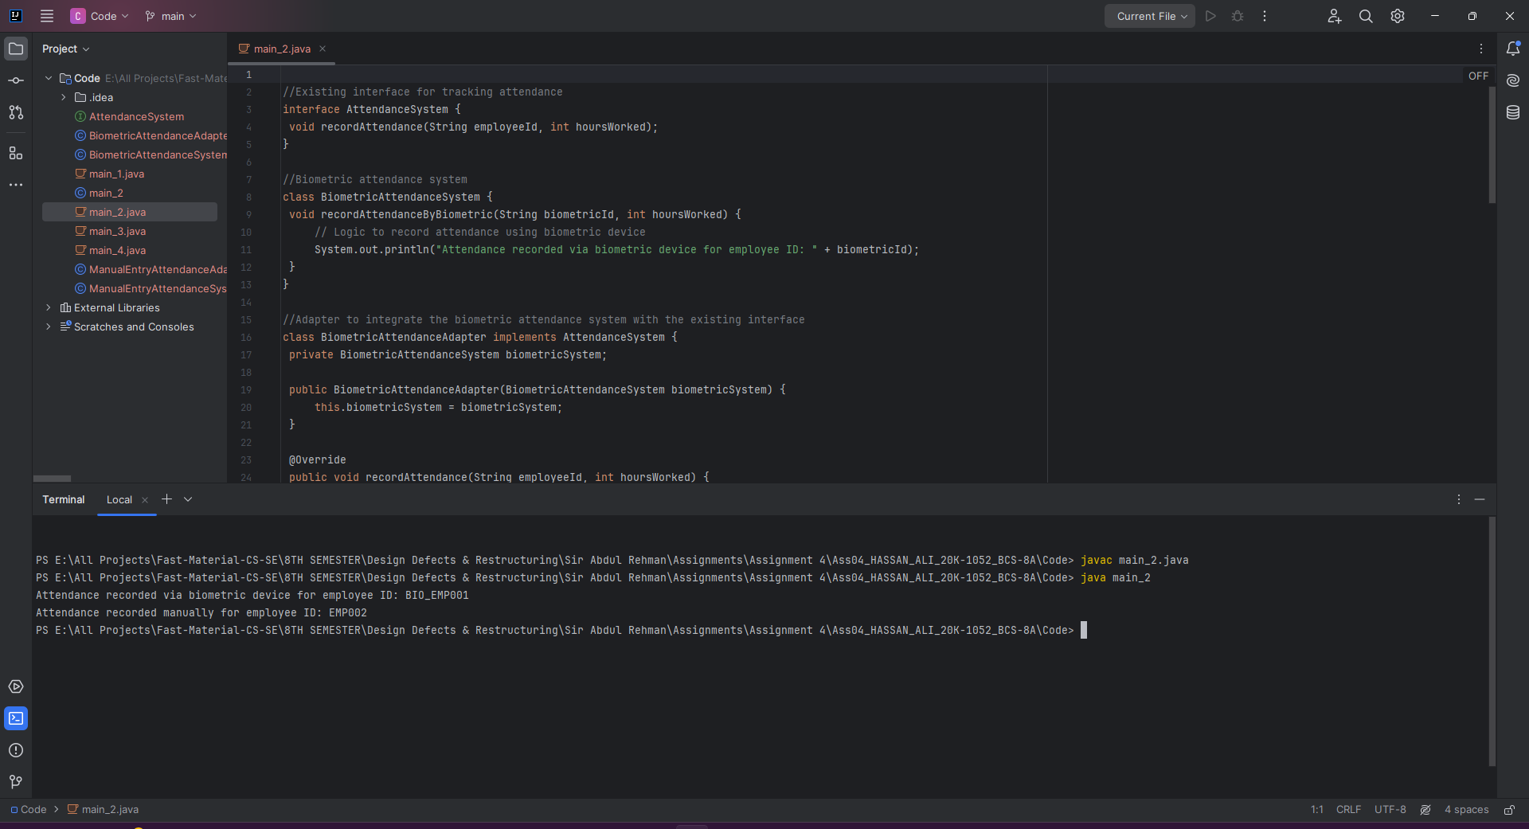

**Class Diagram**

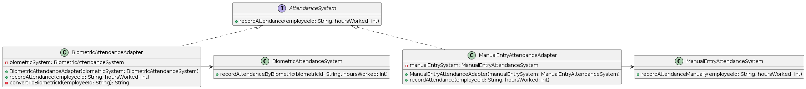

}

}

**Activity Diagram**

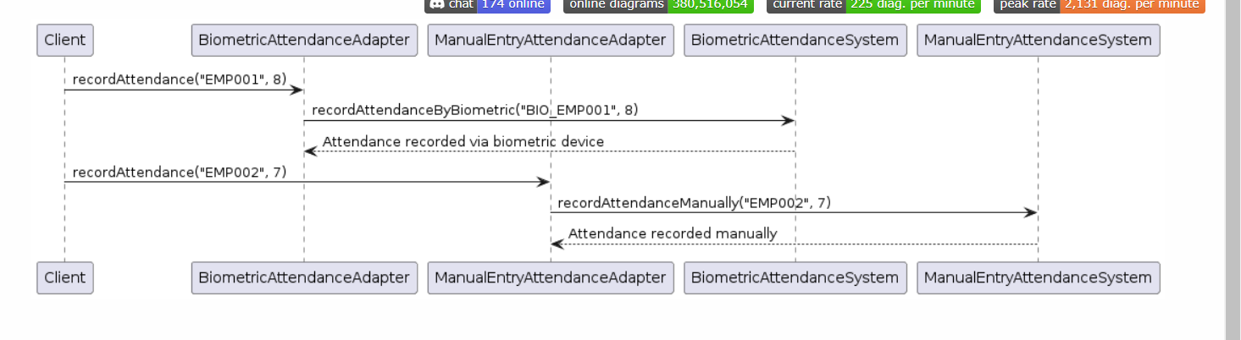

**Explanation:**

Compatibility with Existing Systems: The Adapter pattern is used to make the existing attendance tracking systems compatible with the common AttendanceSystem interface. This is beneficial when integrating legacy systems or third-party components into the HR system without requiring changes to their implementation.

Uniform Interface: By providing a common interface (AttendanceSystem), the Adapter pattern allows the client code to interact with different types of attendance systems in a consistent manner. This promotes code reusability and simplifies maintenance, as the client code does not need to be modified when integrating new types of attendance systems.

Encapsulation of System-Specific Logic: The adapters (BiometricAttendanceAdapter and ManualEntryAttendanceAdapter) encapsulate the logic required to adapt the methods of the existing attendance systems to the AttendanceSystem interface. This encapsulation isolates the system-specific details from the client code, making it easier to manage and maintain.

Flexibility and Extensibility: The Adapter pattern provides flexibility by allowing new types of attendance systems to be integrated into the HR system without modifying the client code. This extensibility is crucial in scenarios where new attendance tracking technologies may be adopted or when integrating with diverse systems used by different departments or organizations.

Simplified Integration: The Adapter pattern simplifies the integration of disparate systems by providing a layer of abstraction between the client code and the underlying implementation details of the attendance tracking systems. This simplification reduces the complexity of the integration process and improves overall system maintainability.

* 1. **Façade Pattern**

/**/Employee class representing employee information**

**class Employee {**

**private String name;**

**private String position;**

**private double hourlyRate;**

**public Employee(String name, String position, double hourlyRate) {**

**this.name = name;**

**this.position = position;**

**this.hourlyRate = hourlyRate;**

**}**

**public String getName() {**

**return name;**

**}**

**public String getPosition() {**

**return position;**

**}**

**public double getHourlyRate() {**

**return hourlyRate;**

**}**

**}**

**//AttendanceTracker class for tracking employee attendance**

**class AttendanceTracker {**

**public void recordAttendance(String employeeId, int hoursWorked) {**

**// Logic to record attendance**

**System.*out*.println("Attendance recorded for employee ID: " + employeeId);**

**}**

**}**

**//SalaryCalculator class for calculating employee salaries**

**class SalaryCalculator {**

**public double calculateSalary(double hourlyRate, int hoursWorked) {**

**return hourlyRate * hoursWorked;**

**}**

**}**

**//ReportingSystem class for generating reports**

**class ReportingSystem {**

**public void generateReport(String reportType) {**

**// Logic to generate reports**

**System.*out*.println("Generating " + reportType + " report...");**

**}**

**}**

**//HRFacade class acting as a facade for HR managers**

**class HRFacade {**

**private AttendanceTracker attendanceTracker;**

**private SalaryCalculator salaryCalculator;**

**private ReportingSystem reportingSystem;**

**public HRFacade() {**

**this.attendanceTracker = new AttendanceTracker();**

**this.salaryCalculator = new SalaryCalculator();**

**this.reportingSystem = new ReportingSystem();**

**}**

**public void recordAttendance(String employeeId, int hoursWorked) {**

**attendanceTracker.recordAttendance(employeeId, hoursWorked);**

**}**

**public double calculateSalary(double hourlyRate, int hoursWorked) {**

**return salaryCalculator.calculateSalary(hourlyRate, hoursWorked);**

**}**

**public void generateReport(String reportType) {**

**reportingSystem.generateReport(reportType);**

**}**

**}**

**//Client code**

**public class main_3 {**

**public static void main(String[] args) {**

**HRFacade hrFacade = new HRFacade();**

**// HR managers can use the facade to interact with the subsystems**

**hrFacade.recordAttendance("EMP001", 8);**

**double salary = hrFacade.calculateSalary(30.0, 40);**

**System.*out*.println("Calculated salary: $" + salary);**

**hrFacade.generateReport("Attendance");**

**Output**

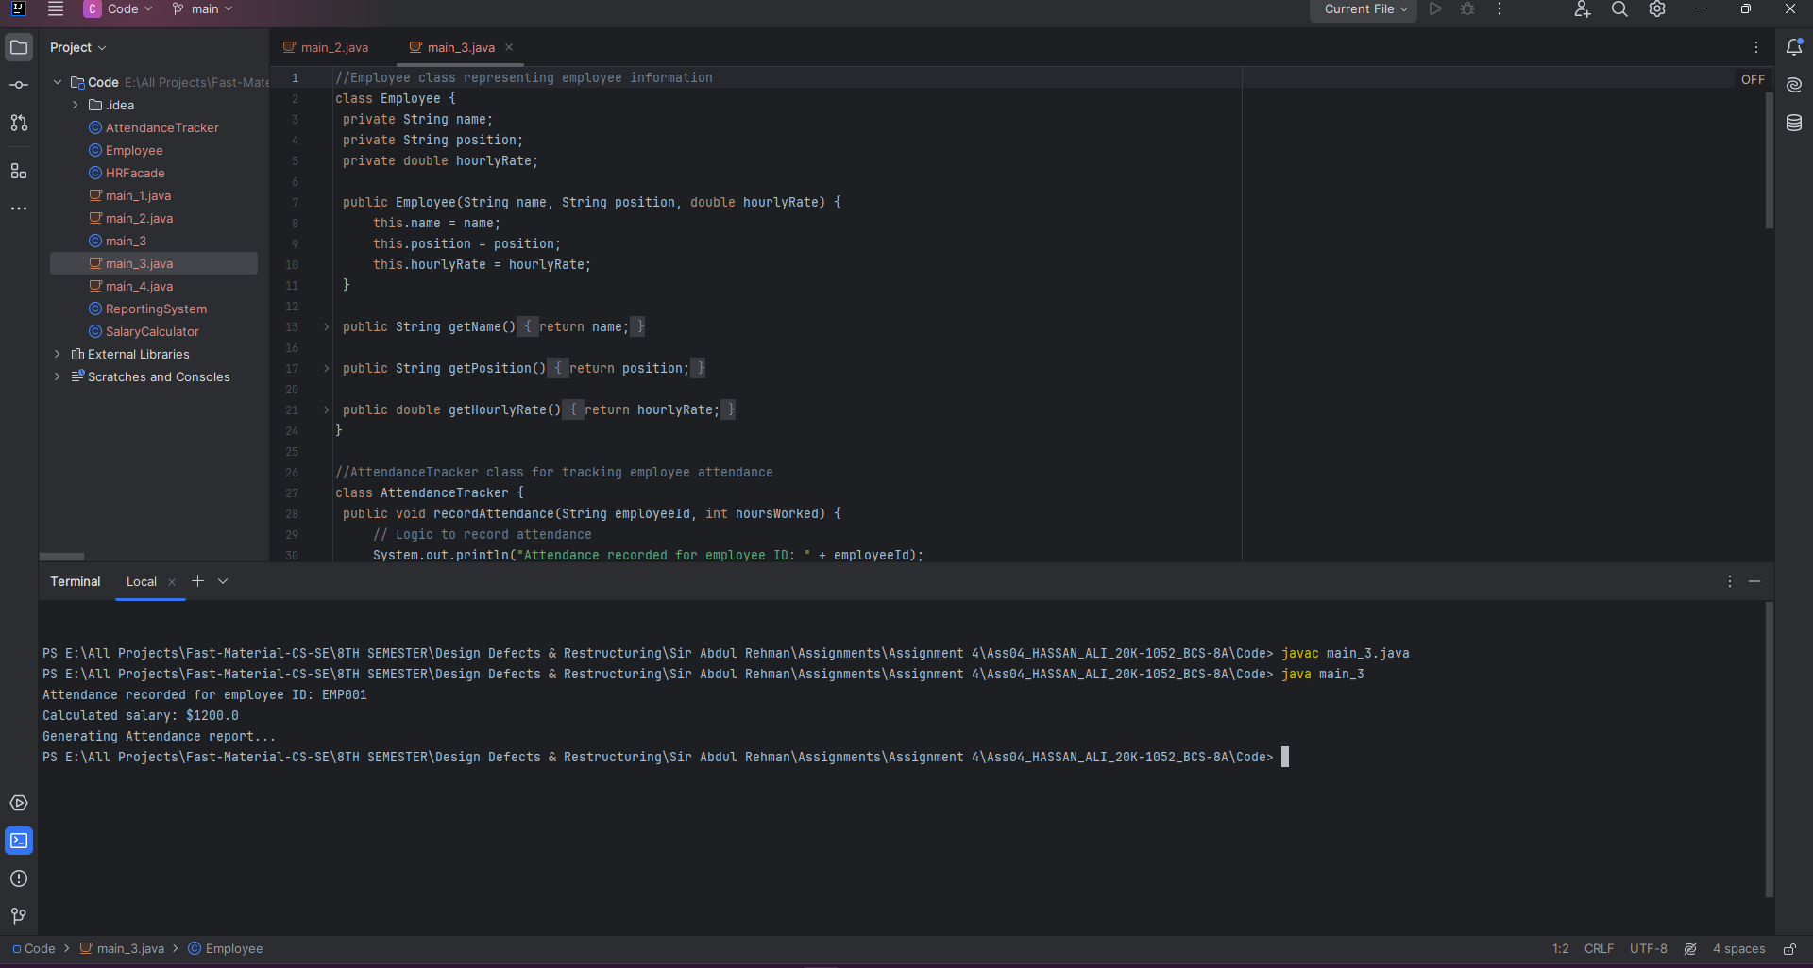 **Class Diagram  
**

**Activity Diagram:  
**

**Explanation:**

Simplified Interface: The Facade pattern provides a simplified interface (HRFacade) for HR managers to interact with complex subsystems. This abstraction shields the client code from the complexities of the individual subsystems, making it easier to understand and use.

Encapsulation of Complexity: The Facade pattern encapsulates the complexity of the underlying subsystems within the HRFacade class. This encapsulation promotes code maintainability and reduces the risk of errors by hiding the implementation details from the client code.

Reduced Coupling: By providing a single point of access to the subsystems, the Facade pattern reduces coupling between the client code and the individual subsystems. This decoupling allows for easier modifications and enhancements to the subsystems without affecting the client code.

Promotes Reusability: The Facade pattern promotes reusability by providing a well-defined interface (HRFacade) that can be used by multiple clients. This reusability simplifies the development process and reduces code duplication.

Eases Integration: The Facade pattern eases the integration of complex subsystems by providing a unified interface that abstracts away the details of the individual components. This simplifies the process of integrating new subsystems or replacing existing ones in the HR system.

Improves Maintainability: By encapsulating the complexity of the subsystems and providing a clear separation of concerns, the Facade pattern improves the maintainability of the HR system. Changes to the subsystems can be made within the HRFacade class without impacting the client code, making it easier to maintain and update the system over time.

* 1. **Template Pattern**

**// Abstract class defining the template method**

**abstract class ReportGenerator {**

**// Template method defining the algorithm for generating a report**

**public final void generateReport() {**

**// Common steps for generating a report**

**System.out.println("Generating report header...");**

**generateTitle();**

**generateEmployeeList();**

**generateBody();**

**generateFooter();**

**}**

**// Hook methods to be implemented by subclasses**

**protected abstract void generateTitle();**

**protected abstract void generateEmployeeList();**

**protected abstract void generateBody();**

**protected abstract void generateFooter();**

**}**

**// Concrete subclass implementing the template method for generating Attendance Report**

**class AttendanceReportGenerator extends ReportGenerator {**

**// Concrete implementation of hook methods for Attendance Report**

**@Override**

**protected void generateTitle() {**

**System.out.println("Attendance Report");**

**}**

**@Override**

**protected void generateEmployeeList() {**

**System.out.println("Employee List for Attendance Report:");**

**// Code to retrieve and print employee list**

**}**

**@Override**

**protected void generateBody() {**

**System.out.println("Generating attendance data...");**

**// Code to generate attendance data and print**

**}**

**@Override**

**protected void generateFooter() {**

**System.out.println("Attendance report generated successfully.");**

**}**

**}**

**// Concrete subclass implementing the template method for Performance Report**

**class PerformanceReportGenerator extends ReportGenerator {**

**// Concrete implementation of hook methods for Performance Report**

**@Override**

**protected void generateTitle() {**

**System.out.println("Performance Report");**

**}**

**@Override**

**protected void generateEmployeeList() {**

**System.out.println("Employee List for Performance Report:");**

**// Code to retrieve and print employee list**

**}**

**@Override**

**protected void generateBody() {**

**System.out.println("Generating performance data...");**

**// Code to generate performance data and print**

**}**

**@Override**

**protected void generateFooter() {**

**System.out.println("Performance report generated successfully.");**

**}**

**}**

**// Concrete subclass implementing the template method for Payroll Report**

**class PayrollReportGenerator extends ReportGenerator {**

**// Concrete implementation of hook methods for Payroll Report**

**@Override**

**protected void generateTitle() {**

**System.out.println("Payroll Report");**

**}**

**@Override**

**protected void generateEmployeeList() {**

**System.out.println("Employee List for Payroll Report:");**

**// Code to retrieve and print employee list**

**}**

**@Override**

**protected void generateBody() {**

**System.out.println("Generating payroll data...");**

**// Code to generate payroll data and print**

**}**

**@Override**

**protected void generateFooter() {**

**System.out.println("Payroll report generated successfully.");**

**}**

**}**

**// Client code**

**public class Main {**

**public static void main(String[] args) {**

**// Generate Attendance Report**

**System.out.println("Generating Attendance Report:");**

**AttendanceReportGenerator attendanceReportGenerator = new AttendanceReportGenerator();**

**attendanceReportGenerator.generateReport();**

**System.out.println();**

**// Generate Performance Report**

**System.out.println("Generating Performance Report:");**

**PerformanceReportGenerator performanceReportGenerator = new PerformanceReportGenerator();**

**performanceReportGenerator.generateReport();**

**System.out.println();**

**// Generate Payroll Report**

**System.out.println("Generating Payroll Report:");**

**PayrollReportGenerator payrollReportGenerator = new PayrollReportGenerator();**

**payrollReportGenerator.generateReport();**

**}**

**}**

**Output:**

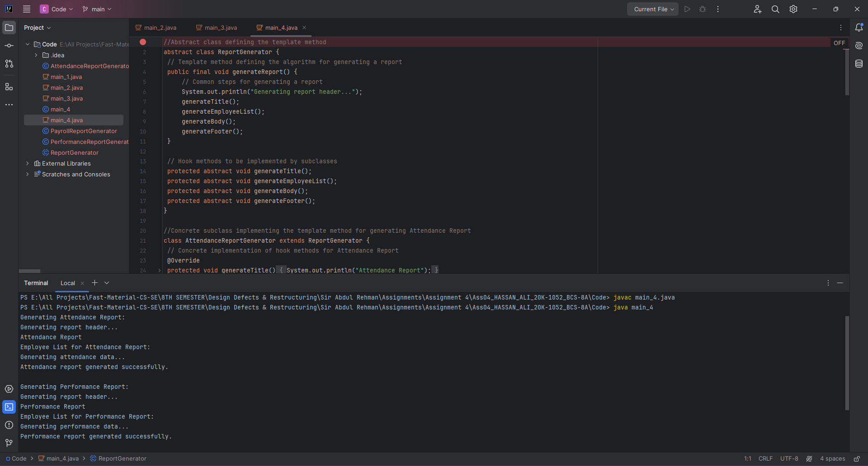

**Class Diagram:**

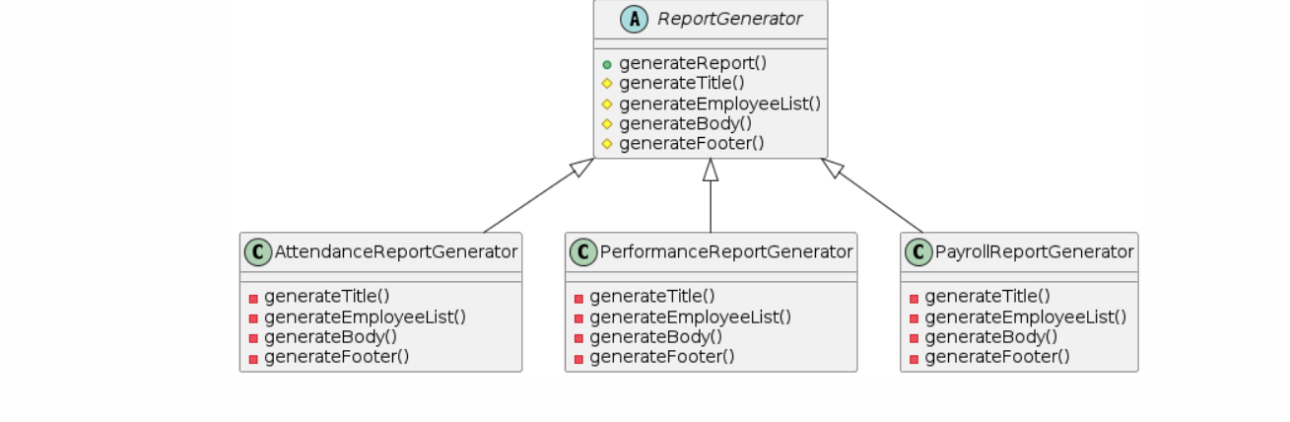

**Activity Diagram:**

**Explanation:**

Code Reusability: The Template Method pattern promotes code reusability by defining a common algorithm (generateReport()) in the base class (ReportGenerator). Subclasses can reuse this algorithm without duplicating code, resulting in a more maintainable and scalable system.

Consistency and Standardization: By defining a common structure for report generation in the base class, the Template Method pattern ensures consistency and standardization across different types of reports. HR managers can expect similar formatting and layout for all reports, enhancing the user experience and reducing confusion.

Encapsulation of Common Behavior: The Template Method pattern encapsulates common behavior (e.g., generating a report header, footer) in the base class, allowing subclasses to focus on implementing specific variations (e.g., generating report body for attendance, performance, payroll reports). This separation of concerns improves code readability and maintainability.

Flexibility and Customization: Despite providing a common structure, the Template Method pattern allows subclasses to customize specific steps of the algorithm as needed. Subclasses can override hook methods (generateTitle(), generateEmployeeList(), generateBody(), generateFooter()) to tailor the report generation process to their specific requirements, providing flexibility and customization options.

Ease of Extension: The Template Method pattern makes it easy to extend the system with new types of reports. Developers can create new subclasses that implement the necessary variations while leveraging the existing infrastructure provided by the base class. This extensibility simplifies the addition of new features to the system without modifying existing code.

Improved Maintainability: By promoting code reuse, encapsulation, and consistency, the Template Method pattern improves the maintainability of the HR system. Changes to the report generation process can be made in the base class, affecting all subclasses uniformly. This centralization of code reduces the risk of errors and simplifies maintenance tasks.

1. **compare advantages and disadvantages of each pattern that you have used.**

**1. Factory Pattern:**

Advantages:

Encapsulation of Object Creation: The Factory pattern encapsulates the creation of objects, allowing the client code to be decoupled from the concrete implementations of the created objects.

Flexibility: It provides a centralized place to manage object creation, making it easier to modify or extend the creation process without affecting the client code.

Abstraction: It promotes abstraction by defining an interface for creating objects, allowing clients to work with abstract types rather than concrete implementations.

Disadvantages:

Complexity: Implementing a Factory pattern can introduce additional complexity, especially in scenarios with multiple types of objects and creation logic.

Increased Code Overhead: Introducing factory classes and interfaces may increase code overhead, especially for simple object creation scenarios.

Potential Overhead: In some cases, using a Factory pattern may introduce overhead due to the additional layer of abstraction and indirection involved in object creation.

**2. Adapter Pattern:**

Advantages:

Compatibility: The Adapter pattern enables the integration of incompatible interfaces or systems, allowing them to work together seamlessly.

Flexibility: It provides a way to adapt existing code or systems without modifying their original implementation, promoting code reuse and flexibility.

Encapsulation: Adapters encapsulate the complexity of interface conversion, hiding implementation details from the client code.

Maintainability: It improves maintainability by isolating changes in one system from affecting others, making it easier to modify or extend the system.

Disadvantages:

Complexity: Implementing adapters can add complexity to the system, especially when dealing with multiple interfaces or complex adaptation logic.

Potential Performance Overhead: Adapting interfaces at runtime may introduce performance overhead, especially in performance-critical systems.

Increased Indirection: Adapters introduce an additional layer of indirection, which may impact code readability and performance.

**3. Facade Pattern:**

Advantages:

Simplified Interface: The Facade pattern provides a simple interface to a complex subsystem, hiding its complexity from clients and promoting ease of use.

Encapsulation: It encapsulates the interactions between clients and subsystems, reducing coupling and promoting modularity.

Flexibility: Facades can provide multiple simplified interfaces tailored to different client requirements, enhancing flexibility.

Promotes Code Organization: Facades promote code organization by centralizing complex subsystem interactions in a single place, improving code maintainability.

Disadvantages:

Limited Control: Facades may provide limited control over subsystems, making it challenging to access or modify specific subsystem functionalities.

Potential Overhead: Introducing a Facade may add overhead, especially if it involves additional processing or abstraction.

Potential for Abstraction Leakage: If not designed carefully, a Facade may leak implementation details of the subsystem, violating the principle of encapsulation.

**4. Template Method Pattern:**

Advantages:

Code Reuse: The Template Method pattern promotes code reuse by defining a common algorithm in the base class and allowing subclasses to override specific steps.

Flexibility: It provides flexibility by allowing subclasses to customize parts of the algorithm without changing its structure, facilitating variations in behavior.

Promotes Consistency: Template methods ensure consistency in behavior across subclasses by enforcing a common structure for algorithm execution.

Encapsulation: Template methods encapsulate the overall algorithm, hiding implementation details from subclasses and promoting modular design.

Disadvantages:

Inflexibility: Subclasses may be constrained by the structure imposed by the template method, limiting their ability to deviate from the predefined algorithm.

Potential for Code Duplication: If not used carefully, the Template Method pattern may lead to code duplication, especially if subclasses override large portions of the template method.

Complexity: Implementing the Template Method pattern may introduce additional complexity, especially in scenarios with multiple variations of the algorithm or complex inheritance hierarchies.

1. **A detailed critical analysis on how this solution can be implemented using other patterns (apart the four that you have used) and its consequences and further improvements that can be achieved in architecture.**

**Decorator Pattern:**

Application: The Decorator pattern can be used to dynamically add responsibilities (such as additional functionalities or behaviors) to individual objects without affecting other objects of the same class. For example, decorators could be used to add additional functionalities to employee objects, such as bonus calculation or performance evaluation.

Consequences: Applying the Decorator pattern allows for flexible extension of functionalities without modifying existing code. However, it can lead to a proliferation of small classes if used excessively, potentially complicating the system.

Further Improvements: To avoid excessive class proliferation, careful consideration should be given to the granularity of decorators and the hierarchy of responsibilities.

**Iterator Pattern:**

Application: The Iterator pattern can be used to traverse collections of employee data in a uniform manner without exposing the underlying implementation details. For example, it can facilitate iterating over lists of employees for generating reports or processing payroll.

Consequences: By encapsulating the iteration logic, the Iterator pattern promotes separation of concerns and enhances code maintainability. However, implementing custom iterators for different types of collections may introduce additional complexity.

Further Improvements: Consider providing custom iterators tailored to specific use cases to optimize performance and simplify usage for clients.

**Observer Pattern:**

Application: The Observer pattern can be used to establish relationships between HR system components, allowing them to react to changes in each other's state. For example, HR managers could be observers of employee attendance data, receiving notifications when attendance records are updated.

Consequences: Applying the Observer pattern promotes loose coupling between components and facilitates communication in a reactive manner. However, managing subscriptions and notifications efficiently can be challenging, especially in large systems.

Further Improvements: Consider using event-driven architectures or message brokers to manage notifications efficiently and asynchronously.

**Proxy Pattern:**

Application: The Proxy pattern can be used to control access to sensitive or remote resources, such as employee data stored in a database or accessed through a web service. For example, a proxy object could handle authentication and authorization before allowing access to employee records.

Consequences: Applying the Proxy pattern enhances security and performance by providing a controlled interface to access resources. However, introducing proxies may introduce additional overhead, especially if they involve remote communication or caching.

Further Improvements: Use lazy initialization or caching strategies to optimize resource usage and minimize overhead when using proxies for remote resources.

**Command Pattern:**

Application: The Command pattern can be used to encapsulate requests as objects, allowing for parameterization and queuing of requests, undo/redo functionality, or logging of operations. For example, commands could represent actions such as adding or updating employee records.

Consequences: Applying the Command pattern promotes decoupling between requestors and receivers of commands, facilitating extensibility and composability of operations. However, managing command objects and their execution may introduce additional complexity.

Further Improvements: Consider using command queues, undo stacks, or logging strategies to enhance the robustness and flexibility of the Command pattern implementation.

**Composite Pattern:**

Application: The Composite pattern can be used to treat individual objects and compositions of objects uniformly. For example, employee hierarchies could be represented as composite structures, allowing operations to be applied recursively to groups of employees.

Consequences: Applying the Composite pattern simplifies the handling of complex hierarchical structures by providing a unified interface. However, ensuring consistency and efficiency in operations across different types of composite and leaf nodes may require careful design.

Further Improvements: Use caching or memoization techniques to optimize performance when performing operations on composite structures with large numbers of nodes.

**State Pattern:**

Application: The State pattern can be used to model the behavior of HR system components in different states, allowing them to change their behavior dynamically based on internal state changes or external events. For example, employee objects could transition between active, inactive, and on-leave states, with different behaviors associated with each state.

Consequences: Applying the State pattern promotes modularity and extensibility by encapsulating state-specific behavior in separate state objects. However, managing transitions between states and ensuring consistency in behavior across different states may require careful coordination.

Further Improvements: Use state machines or finite state automata to formalize state transitions and ensure correctness in complex stateful behaviors.

**Chain of Responsibility Pattern:**

Application: The Chain of Responsibility pattern can be used to decouple senders of requests from receivers by allowing multiple objects to handle a request in a chain-like fashion. For example, request processing in the HR system, such as approval workflows or validation checks, could be implemented using a chain of responsibility.

Consequences: Applying the Chain of Responsibility pattern promotes flexibility and extensibility by enabling dynamic configuration of request handling chains. However, ensuring proper termination of the chain and preventing potential loops or excessive chaining can be challenging.

Further Improvements: Use well-defined protocols or contracts to standardize request handling across chain elements and ensure proper error handling and logging to diagnose and resolve issues in chain processing.